**Worksheet-3.2**

**Student Name**: Sahil Kaundal **UID:** 21BCS8197

**Branch**: CSE(LEET) **Section/Group:** 807/B

**Semester**: 4th **Date of Performance**: 04/05/2022

**Subject Name**: CN Lab **Subject Code:** 20CSP-257

1. **Aim/Overview of the practical:**

Create a network to implement the DHCP server.

1. **Task to be done/ Which logistics used:**

Create a network to implement the DHCP server.

DHCP (**Dynamic Host Configuration Protocol**) configuration is performed on routers to assign an IP address, subnet mask, gateway address ad DNS server address to the host systems.

1. Build the network topology in packet tracer.
2. Configure static IP address on the server (192.168. 1.2/24).
3. Now configure DHCP service on the generic server.
4. Finally, enable DHCP configuration on each PC.
5. **Apparatus/Simulator used** **(For applied/experimental sciences/materials-based labs):**

Cisco Packet Tracer

1. **Steps:**

* Build the network topology in packet tracer.
* Configure static IP address on the server (192.168. 1.2/24).
* Now configure DHCP service on the generic server.
* Finally, enable DHCP configuration on each PC.

**Step-1:**  
A network topology is created in the Cisco Packet Tracer, which includes a router, a switch, and three host systems connected to a network.

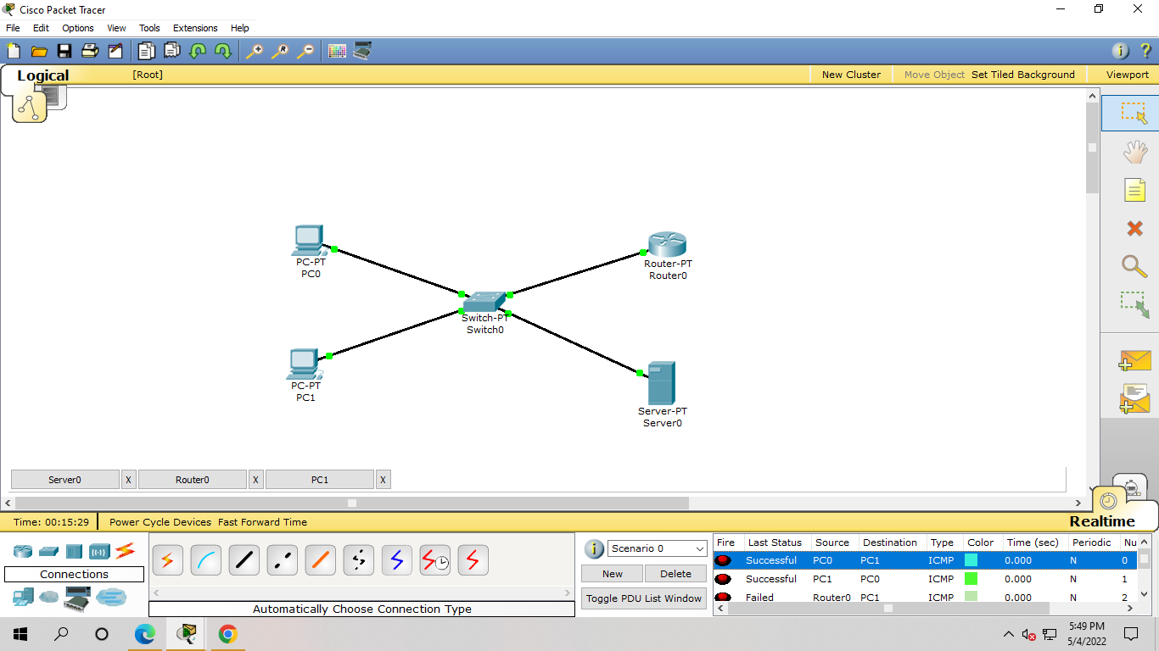

*Network Topology*

**Step-2:**   
Command Line Interface of the router is accessed and high-lighted commands are executed to successfully configure the DHCP. At first, the ‘IP DHCP pool pool_name’ command is executed. After this, the network address is defined along with its subnet mask. And further, the ‘default-router IP-address’ command is used to define the default route address.

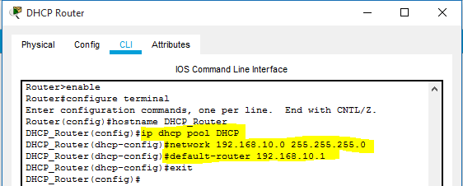

*Creation of DHCP pool*

**Step-3:**  
In this step, a range of IP addresses is excluded from the addresses defined in the subnet mask of the DHCP pool. Excluded IP addresses will be not assigned to any host system in the network.

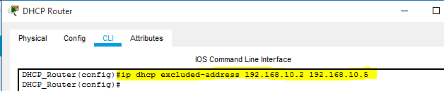

*Command used to exclude IP range*

**Step-4:**   
The interface of the router connected with the switch is assigned with the IP address defined as the default router during the DHCP configuration. This route will be taken by the data packets to reach their destination system. Also, the ‘no shutdown command is used to change the state of the connected interface to up.

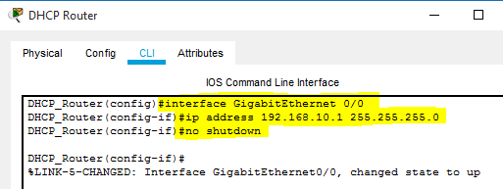

*Assigning of IP address to router’s interface*

**Step-5:**  
A successful connection is established between all the devices connected in a network. In further steps, host systems in the network are assigned with dynamic IP and default gateway address by the DHCP service configured on the router.



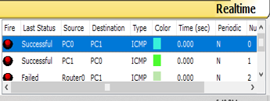

*All the devices are successfully connected*

**Step-6:**  
Desktop settings of a host system are accessed and the DHCP option is selected. DHCP request forwarded by the system is acknowledged and IP address, associated subnet mask, and default gateway address are assigned to it.

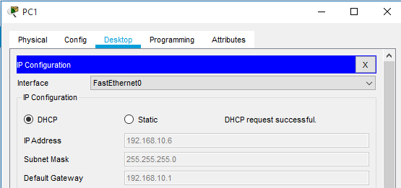

*The dynamic IP address assigned to the Host System*

Another host system deployed in the network is assigned with required logical addresses through the DHCP server configured on Cisco Router. In addition, IP addresses defined in the excluded range are not assigned to the computer systems.

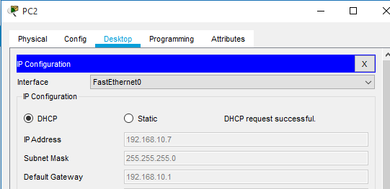

*Logical addresses are assigned to the Host System*

**Step-7:**  
To check the connectivity between the host systems, the ‘ping’ command is used to exchange data packets. All the data packets are successfully transferred, which ensures that a communication channel is established.

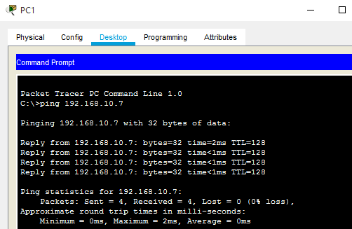

*Connectivity Testing*

**Result: -**

I have successfully completed this experiment.

**Learning outcomes (What I have learnt):**

1. Created a network that implement the DHCP server.

**Evaluation Grid (To be created as per the SOP and Assessment guidelines by the faculty):**

|  |  |  |  |
| --- | --- | --- | --- |
| Sr. No. | Parameters | Marks Obtained | Maximum Marks |
| 1. |  |  |  |
| 2. |  |  |  |
| 3. |  |  |  |
|  |  |  |  |